Juvenile Justice in Arkansas

A Long Road to a Promising Future

By Paul Kelly

Arkansas Advocates for Children and Families  
December 2008

*Support for this report was provided by the Annie E. Casey Foundation. We thank the foundation for its support but acknowledge that the findings and conclusions presented in this report are those of the author alone, and do not necessarily reflect the opinion of the foundation.*

Union Station, Suite 306  
1400 W. Markham  
Little Rock, AR 72201  
(501) 371-9678

614 E. Emma, Suite 127  
Springdale, AR 72764  
(479) 927-9800

www.aradvocates.org



An Analysis of Juvenile Justice in Arkansas

For decades Arkansas has struggled to effectively address the needs of juvenile offenders. Now, with significant decreases in juvenile arrests and commitments to the DHS Division of Youth Services, Arkansas can concentrate on the underlying problems that bring youth into our juvenile justice system.  There are proven methods to effectively attend to the needs of these youth and a promising effort by key stakeholders to bring real change.

## Summary

* The most important question for Arkansas’s juvenile justice system is how best to address problems of troubled youth so they can live safely in their family and community without being brought into the juvenile justice system.
* Arkansas still does not have the capacity to track juvenile offenders across the juvenile and adult justice systems.
* Juvenile crime is decreasing. After rising 41.7 percent between 1989 and 1998, juvenile arrests have now decreased 41 percent from a high of 20,032 arrests in 1998 to 11,814 in 2007.
* Only 6 percent of delinquent youth were committed to the DHS Division of Youth Services from July 1, 2006 thru June 30, 2007. That compares to 18 percent of delinquent youth committed between 1990 and 1995.
* Youth confined to the Arkansas Juveniles Assessement and Treatment Center (AJATC) have behavior problems complicated by co-occurring disorders. For example, 22 of the 54 youth with conduct disorders (41 percent) also had a substance abuse disorder.

*Support for this report was provided by the Annie E. Casey Foundation. We thank the foundation for its support but acknowledge that the findings and conclusions represented in this report are those of the author alone, and do not necessarily reflect the opinion of the foundation.*

* Our sense of justice and our knowledge about how to effectively treat these youth should dictate a more rational early involvement and long-term approach to ensure their future success and reduced burden on society.

## stockxpertcom_id300059_5e735c8317e4842f29808a5545acce46Introduction

A

rkansas’s juvenile justice system has undergone significant reforms, periodic revisions, and been the subject of many legislative hearings to address reoccurring problems during the past several decades. This is a system of justice, separate from the adult system, that was established for youthful offenders who society determined were in need of special consideration. It is a justice system that too often struggles to find the right balance between the demand for public safety and the importance of supporting the needs of troubled youth so that they become successful adults. It is too often shaped by public opinion that succumbs to a more punitive approach in reaction to increases in juvenile crime or incidents like the school shootings in Jonesboro that “blur the well-established differences between youth and adults.”[[1]](#endnote-2)

**“Among all the policy areas affecting vulnerable children and families, juvenile justice has probably suffered the most glaring gaps between best practices and common practice, between what we know and what we most often do.”**

Douglas Nelson, President and CEO, Annie E. Casey Foundation

This search for a balance between public safety and rehabilitation is a false dichotomy. It ignores the more important question of how best to address problems of troubled youth so they can live safely in their family and community without being brought into the juvenile justice system. That is the question at the heart of juvenile justice reform efforts now underway in Arkansas. This brief report will summarize past problems, present new data, and offer some perspective on how best to proceed in helping youth remain in their family and community.

## Background

M

ore than ten years ago Arkansas Advocates for Children and Families (AACF) conducted a comprehensive study of the Arkansas juvenile justice system and found significant increases in the number of juveniles entering all segments of the justice system between 1990 and 1995. This included a 31 percent increase in youth committed to the Department of Human Services Division of Youth Services (DYS), a 99 percent increase in juvenile cases filed in adult court, and a 44 percent increase in juveniles entering the Arkansas Department of Corrections. Racial disparity was also evident. Non-white juvenile offenders were over-represented in most all components of the justice system, particularly in those segments with the highest sanctions. There were also significant differences in the sanctions imposed on non-white and white juveniles for all six years of the study. The length of time held and the percentage of time served for nonwhites was generally higher than that of whites. This disparity was most evident in the juvenile jail population, but the trend also held true across all segments of the justice system.[[2]](#endnote-3)

A major finding of the AACF study was that Arkansas did not have the capacity to track juvenile offenders across the juvenile and adult justice systems. It was not possible to accurately follow youth from the time they entered and exited the juvenile justice system, much less follow them through the adult system. Without this capacity it is impossible to determine the impacts that judicial intervention has on the life of these youth. This problem continues today.

A lot has happened since the AACF report was published ten years ago. The Arkansas Crime Information Center reports that juvenile arrests, after rising 41.7 percent between 1989 and 1998[[3]](#endnote-4), have now decreased 41 percent from a high of 20,032 arrests in 1998 to 11,814 in 2007.[[4]](#endnote-5) A recent report commissioned by DYS, *Juvenile Justice Reform in Arkansas*, indicates that the number of commitments to DYS has decreased between 1997 and 2007 with significant drops occurring between 2001 and 2004. However, African American youth continue to be disproportionately committed to DYS. In 2007 49 percent of all commitments statewide were African American. In Arkansas only 20 percent of children and youth are African American[[5]](#endnote-6), indicating a statewide disproportional commitment rate of 2.45. The level and degree of disproportionately varies depending on judicial district.[[6]](#endnote-7)

More than 90 percent of all commitments to DYS during the first three quarters of state fiscal year 2008 were for non-violent offenses.

This same report shows that over the past decade, the proportion of commitments for serious offenses has decreased, while the proportion of commitments for misdemeanor offenses has substantially increased. More than 90 percent of all commitments to DYS during the first three quarters of state fiscal year 2008 were for non-violent offenses.[[7]](#endnote-8)

Children and youth are brought before the court to determine if their actions constitute a delinquent act. The court can then impose a variety of consequences on these “adjudicated” delinquents. During state fiscal year 2006 (July 1, 2006 through June 30, 2007) there were a total of 14,229 children and youth adjudicated delinquent in Arkansas.[[8]](#endnote-9) Males accounted for 75 percent of those youth (10,691). Just over half (52 percent) of the delinquents were white, 35 percent were black, in 10 percent of the cases the race of the youth was unknown, and 2 percent were listed as other.

**Disposition of Adjudicated Delinquents in Arkansas**

**July 1, 2006 thru June 30, 2007**

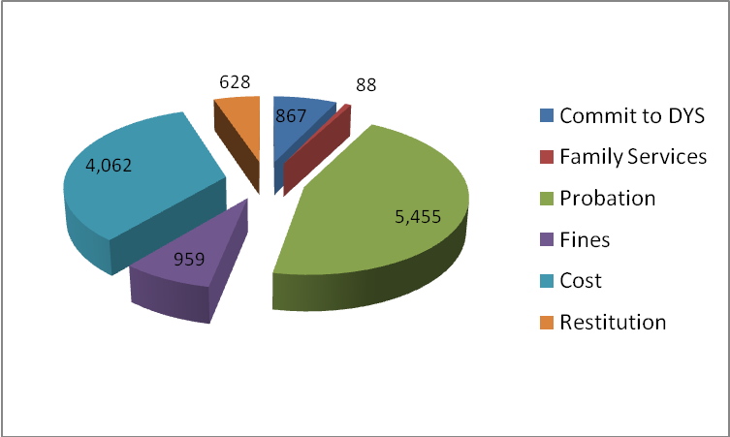

Eight hundred and sixty-seven of these youth (6 percent) were committed to DYS. The majority of these youth were either placed on probation (5,455 or 38 percent) and/or paid court costs (4,062 or 29 percent). Other youth paid fines or restitution. Only 88 (0.6 percent) of the adjudicated youth were ordered to family services (family therapy, parenting classes, or other more intensive family services).

All adjudicated delinquents should be offered support and services to address serious problems identified by those assessing problems and making recommendations to the court. Substance abuse, risky behavior, family conflicts, and school discipline problems that go unattended often result in more serious delinquent behavior. Court decisions about whether a child is committed to DYS or allowed to remain in their homes are influenced by the availability of treatment and intervention resources in their local community. Unfortunately, access to appropriate services continues to be a problem in many areas of the state. There is a long waiting period or travel time for those seeking mental health services. There is a severe lack of substance-abuse treatment services for youth and other family members. The interventions needed to address the variety of challenges facing these families are limited in local communities across the state. These are the youth and families whose needs, if not properly addressed, will likely return to court with more serious offenses.

The overwhelming majority of adjudicated delinquents (94 percent) are not being committed to the DYS. It is the remaining 6 percent of adjudicated youth committed to DYS that are the focus of so much public concern.

The overwhelming majority of adjudicated delinquents (94 percent) are not being committed to the DYS. It is the remaining 6 percent of adjudicated youth committed to DYS that are the focus of so much public concern. Addressing the needs of juvenile delinquents placed in the Arkansas Juvenile Assessment and Treatment Center (AJATC), the state’s most secure facility for juvenile offenders, has proven most difficult and continues to absorb resources and create disturbing headlines.

New information was provided on 113 children and youth admitted to the AJATC on a particular day in the spring of 2008 and provides a snapshot of youth in the AJATC. The youth ranged from 13 to 18 years of age; had an educational level ranging from the 6th grade to GED; and 51 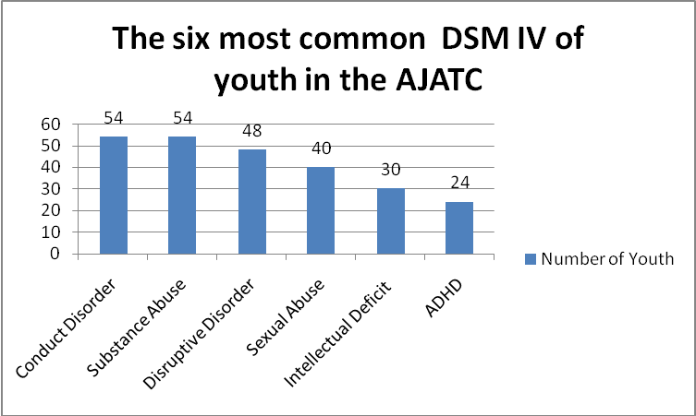percent of the youth were African American.[[9]](#endnote-10) To better understand the mental health and behavioral problems faced by juveniles placed in the AJATC located in Alexander, Arkansas, AACF analyzed data on the diagnosis of the 113 youth. The diagnoses were made according to the Diagnostic and Statistical Manual of Mental Disorders[[10]](#endnote-11) (DSM IV R). This was first time such data were made available on the types of mental health problems faced by these children and youth. The chart at left presents the six most common DSM diagnoses of the youth and illustrates the combination of mental and behavioral health problems that must be properly addressed to ensure successful reintegration into their community and family.

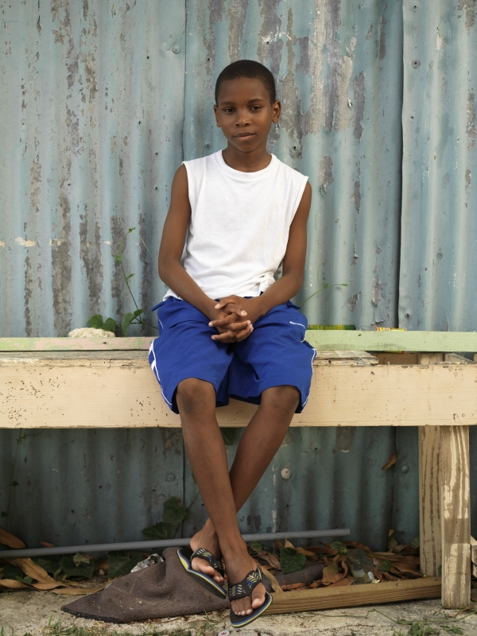The most commonly identified mental health problems of youth in the AJATC reveal that significant behavioral interventions are needed to properly address the needs of these youth. Developing a theraputic environment that sets behavior limits, stuctures daily activities that encourage or reward appropriate behaviors, teaches conflict resolution and impulse control, improves interpersonal relationships, and creates a milieu to help youth practice and internalize appropriate behavior is a major challenge. These youth do not respond well to the typical medical inpatient mental health setting because they often do not require medication interventions, but need more intense behaviorial interventions to keep their disruptive behaviors from interfering with the theraputic milieu of other youth.

The behavior problems confronting these youth are also complicated by the existence of co-occurring disorders or a dual diagnosis that exascerbates inappropriate behaviors that complicate treatment interventions. For example, 54 of the youth (48 percent) had a conduct disorder. Fifty-four youth had a substance abuse disorder. Twenty-two of the 54 youth with conduct disorders (41 percent) also had a substance abuse disorder. The prevelance of dual diagnoses or co-occurring disorders in this population are illustrated by the frequency of multiple disorders in this population (see chart on next page).

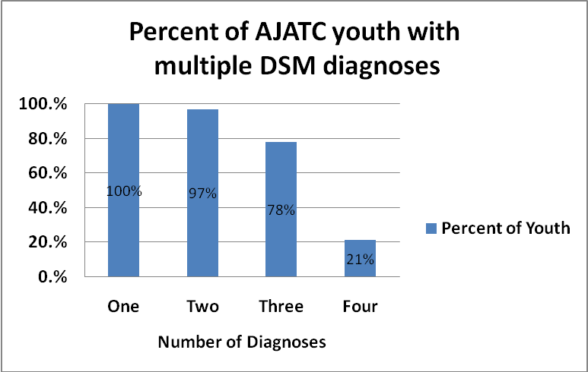Given the multiple problems faced by these youth, the question becomes how best to address the needs of youth whose disruptive behaviors have brought them deep into the juvenile justice system so that they can safely return to their family, their community, and make a successful transition to adulthood. The answer to that question lies first in our “underlying assumptions about the nature of childhood and the meaning of justice.”[[11]](#endnote-12) Researchers have clarified that children and adolescents are not just smaller versions of adults. New brain imaging research reveals that “the brain systems that govern impulse control, planning, and thinking ahead are still developing well beyond age 18.” [[12]](#endnote-13) These youth, although very challenging, are capable of changing their behaviors and developing their capacity to solve problems.

Our sense of justice and our knowledge about how to effectively treat these youth would dictate a more rational early involvement and long-term approach to ensure their future success and reduced burden on society. This is true not only for many of those sent to the AJATC, but for all those adjudicated delinquents that come before our courts. The absence of substance-abuse treatment, the difficulty of treating co-occurring disorders, and the lack of intensive family services in local communities contributes to the state’s inability to properly intervene in the lives of these children and youth.

******Perhaps the most important difference between adolescent and adult lawbreakers is that most youthful offenders will cease lawbreaking as part of the normal maturation process.[[13]](#endnote-14) Seeking solutions to these complex mental health and behavior problems begins with the firm belief that with the proper therapeutic intervention youth can learn and develop new ways of coping with their problems and go on to become productive adults. With that belief, and a commitment to learning from past mistakes, Arkansas can begin to create an effective, humane, and less costly juvenile justice system.

## Looking Ahead

D

uring 2008 both national and state attention has focused on promising developments in states moving toward reforming their juvenile justice system. The 2008 Kids Count Data Book essay, *A Road Map for Juvenile Justice Reform,* focused on the longstanding problems in this system. It discussed the promising new developments across the country that can effectively reduce reliance on secure confinement and ensure both positive outcomes and public safety with community-based therapeutic intervention. In Arkansas continued frustration with failures within the AJATC to maintain occupant safety, to provide educational services, or to adequately address the complex behavioral and psychological needs of youth placed in its care created a renewed sense of urgency and purpose. Established by DYS in 2006, the Arkansas Task Force on Juvenile Justice Reform began gathering data and holding meetings with key stakeholders to assess the current conditions. A recently published assessment of the state juvenile justice system has outlined the problem, the solutions, and the opportunities in Arkansas for genuine reform. The document outlined factors that, if not address, will continue to bring more “high need” juvenile offenders into the juvenile justice system.

* In 2005, there were 12,000 teens in Arkansas ages 16 to 19 that dropped out of high school.[[14]](#endnote-15)
* A growing number of youth are being sent to the secure facilities because of increased “zero tolerance” school discipline approaches and failure of the child welfare system to appropriately intervene with these children, youth and families.
* On March 25, 2008, of the 815 Arkansas youth in DYS residential aftercare programs, the vast majority (almost 83 percent) had some kind of previous contact with the state’s child welfare system (DHS Division of Children and Family Services).[[15]](#endnote-16)

If the existing economic, health, education, child welfare and community systems designed to meet the needs of children, youth and families fail to intervene appropriately when problems arise, the juvenile justice system becomes the place where the consequences of these failures are urgently played out, a place too often without the resources to restore the shattered lives of youth or the strength of families.

## Recommendations

T

he good news is that there are proven and effective methods to address the needs of these youth and families. Arkansas’s neighbor, Missouri, has earned national recognition for its reduced reliance on large secure institutional settings and has moved toward smaller community based therapeutic programs that have reduced costs and improved outcomes for children and youth. Arkansas officials and stakeholders have visited Missouri programs and brought their experts in to share how we might implement those same reforms in Arkansas. Both of the recent reports (The 2008 Kids Count Essay: *A Road Map for Juvenile Justice Reform*, and *Juvenile Justice in Arkansas: Building a Better Future for Youth, Their Families and the Community*) referenced in this issue brief share common themes for promising change:

* Keep youth out of the system by effectively addressing problems when they first arise at school, or when children come in contact with the mental health and child welfare systems. Too many youth end up in the juvenile justice system because their needs are not addressed by public systems better positioned to serve them.
* Reduce reliance on secure facilities by using objective risk screening assessments, creating non-secure alternatives to detention, and using secure detention only for those who pose a significant pubic safety risk.
* Increase reliance on effective community-based services by investing funds and resources in positive youth opportunities, evidence based substance abuse treatment, day treatment programs, and effective therapeutic and behavioral health services
* Strengthen and empower families to help youth succeed by increasing their involvement in juvenile justice decision making, and taking advantage of family strengths in case planning and interventions.
* Ensure safe, healthy, constructive conditions for confinement by creating smaller facilities that reflect normal environments without cells, uniforms, or other trappings of a prison-like environment. Hire motivated, well-trained and well-educated staff that can provide individualized interventions and accountability.

In Arkansas these themes have been further distilled into specific recommendations and a strategic effort to develop action steps to improve the juvenile justice system by the Arkansas Task Force on Juvenile Justice Reform. Creating a sustained commitment to complete this work in Arkansas is most important if change is to be realized. Courage and leadership within the state, the service providers, the juvenile courts, and state policy makers who have learned from the long road that got us here, and who are open to real change based on what research and common sense tells us is best for these youth and their families.

## References

1. A Road Map for Juvenile Justice Reform, 2008 Kids Count Essay, Douglas Nelson, President and CEO, Annie E. Casey Foundation. www.aecf.org [↑](#endnote-ref-2)
2. Juvenile Justice in Arkansas:1990 through 1996, Arkansas Advocates for Children and Families, 1998 [↑](#endnote-ref-3)
3. Arkansas Crime Information Center, Arkansas Crime Trends 1990-1999. Available online at: http://www.acic.org/acic\_pdfs/99/10\_Year\_99.pdf [↑](#endnote-ref-4)
4. Arkansas Crime Information Center, special combined reports of Age of Persons Arrested - State (NIBRS Reporting Agencies) and Age of Persons Arrested- State (Summary Reporting Agencies) for the years 2004 through 2007 [↑](#endnote-ref-5)
5. Population Division, U.S. Census Bureau. "State Single Year of Age and Sex Population Estimates: April 1, 2000 to July 1, 2007," Vintage 2007. Located online at: <http://www.census.gov/popest/datasets.html>. [↑](#endnote-ref-6)
6. Pat Arthur and Time Roche, Juvenile Justice Reform in Arkansas: Building a Better Future for Youth their Families, and the Community. May, 2008 ,page 13 [↑](#endnote-ref-7)
7. Pat Arthur and Time Roche, Juvenile Justice Reform in Arkansas: Building a Better Future for Youth their Families, and the Community. May, 2008, page 14 [↑](#endnote-ref-8)
8. Arkansas Supreme Court, Administrative Office of the Court. Juvenile Court Adjudications-Delinquency/Probation Revocation Petitions. July 1, 2006 through June 30, 2007 [↑](#endnote-ref-9)
9. Report prepared by April Tyler of G4S for the Arkansas Department of Human Services, Division of Youth Services [↑](#endnote-ref-10)
10. The *Diagnostic and Statistical Manual of Mental Disorders* (DSM) is published by the [American Psychiatric Association](http://en.wikipedia.org/wiki/American_Psychiatric_Association) and provides diagnostic criteria for [mental disorders](http://en.wikipedia.org/wiki/Classification_of_mental_disorders). [↑](#endnote-ref-11)
11. The majority of the statements made in this paragraph are excerpts from the essay “Road Map for Juvenile Justice Reform” published in the Annie E. Casey Foundation’s 2008 Kids Count Data Book, written by Douglas W. Nelson, President and CEO. Available at www.aecf.org [↑](#endnote-ref-12)
12. “Less Guilty by Reason of Adolescence.” Issue Brief No. 3 MacArthur Foundation Research Network on Adolescent Development and Juvenile Justice, available at [www.adjj.org/downloads/6093issue\_brief\_3.pdf](http://www.adjj.org/downloads/6093issue_brief_3.pdf) [↑](#endnote-ref-13)
13. Brief of the American Medical Association et al. as Amica Curiae in Support of Respondent, Roper v. Simmons, 543 U.S. (2005) (No.03-633), available at [www.abanet.org/crimjust/juvjus/simmons/ama.pdf](http://www.abanet.org/crimjust/juvjus/simmons/ama.pdf) [↑](#endnote-ref-14)
14. Child Welfare League of America, State Fact Sheet, Arkansas’s Children 2008. Available at http://www.cwla.org/advocacy/statefactsheet/2008/arkansas.htm [↑](#endnote-ref-15)
15. Pat Arthur and Time Roche, Juvenile Justice Reform in Arkansas: Building a Better Future for Youth their Families, and the Community. May, 2008, page 22. [↑](#endnote-ref-16)